Project Executable Files

Date | 09 July 2026
Team ID | xxxxxx
Project Name | OptiCrop: Smart Agricultural Production Optimization Engine
Maximum Marks | 3 Marks

Project Executable Files
This section requires submission of all executable and deployable files for your project. Ensure all files are properly organized, named, and uploaded to the specified submission platform. The evaluator must be able to run or deploy your solution using the provided files and instructions.

Step 1: Submission Checklist

S.No | Item to Submit | Submitted (Yes / No / NA)
1 | Complete source code (all files and folders) | Yes
2 | README / Setup Guide (instructions to run the project) | Yes
3 | requirements.txt / package.json / dependency file | Yes
4 | Database schema / seed files (if applicable) | NA
5 | Environment configuration file (.env.example or similar) | No
6 | Deployed application URL (if hosted) | No
7 | APK / Executable binary (if applicable for mobile/desktop apps) | NA
8 | Dockerfile / Containerization config (if applicable) | NA
9 | Test files and test results | Yes

10 | Demo video or walkthrough (if required) | Yes

Step 2: File / Folder Structure
Provide an overview of your project's file and folder structure below:
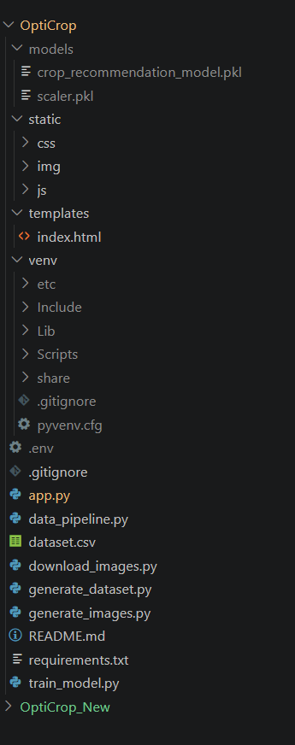

Step 3: Deployment / Access Details

Field | Details
Hosted / Deployed URL | https://opticrop-indol.vercel.app/

Login Credentials (Demo) | Not applicable-the application is openly accessible with no login required
Platform / Hosting Provider | Vercel
Repository Link | https://github.com/ganeshporeddy60-gif/OptiCrop-Smart-Agricultural-Production-Optimization-Engine
Demo Video Link | https://smartopticrop.vercel.app/

Step 4: Run Instructions
Provide clear, step-by-step instructions for the evaluator to run your project locally:

- Download or clone the project repository.
- Open the project folder in Visual Studio Code.
- Create a virtual environment (optional).
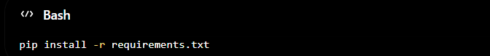
- Install the required dependencies using:
- Run the Flask application:
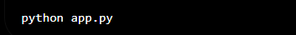
- Open a web browser and visit:
- Enter the required soil and weather parameters.
- Click Predict Crop to view the recommended crop and confidence analysis.

Step 5: Known Issues / Limitations

S.No | Known Issue / Limitation | Workaround / Status
1 | Application currently runs on a local Flask server | Can be deployed on Render for public access
2 | Predictions depend on user-provided input accuracy | Use recent soil testing and weather data
3 | Limited to crops available in the training dataset | Future versions will include additional crop varieties

